**Creating Issue for a Bug of othoba.com on Jira**

* **First step:** Login into Jira account and select scrum and give project name.

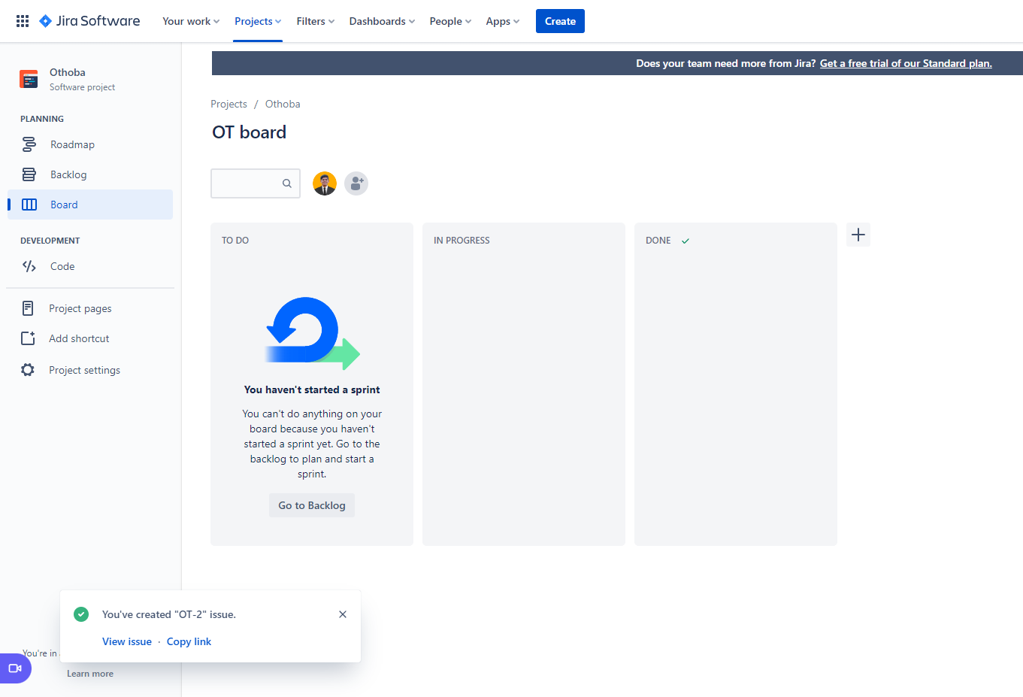

* **Second step:** Click on create and open create issue type.
* **Third step:** Select issue type as “Bug”.
* **Fourth step:** In summary add the summary of the bug as “First Name field is taking invalid formatted data & notshowing any error message”.
* **Fifth step:** In the description write steps to reproduce the bug -

1. Open Othoba.com
2. Tap on sign up button
3. Put an invalid data with numerical numbers and special characters on first name filed.
4. Fill up other fields with valid data.
5. Tap on Register Button.

And Observation about the bug means what is the actual bug -

Registration has been done and no error message has shown.

* **Sixth step:** In assignee give the email address of the developer who’ll fix the given bug.
* **Seventh step:** In reporter put own name.
* **Eighth step:** Click on create button.
* **Here are some visual examples of these given steps:**

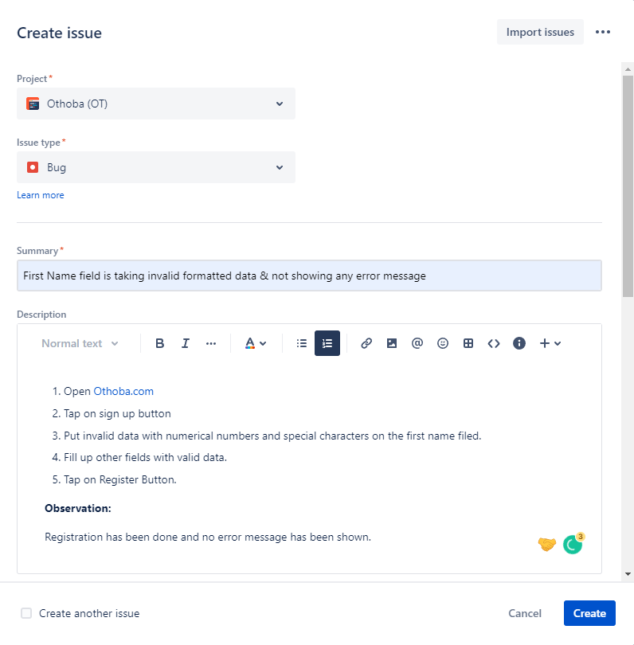

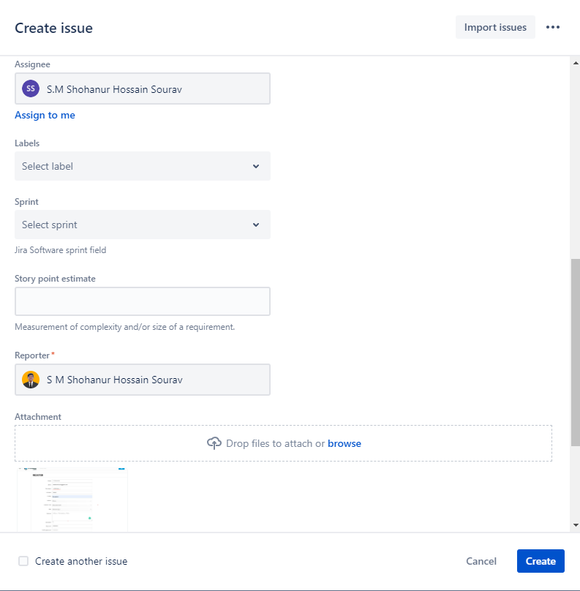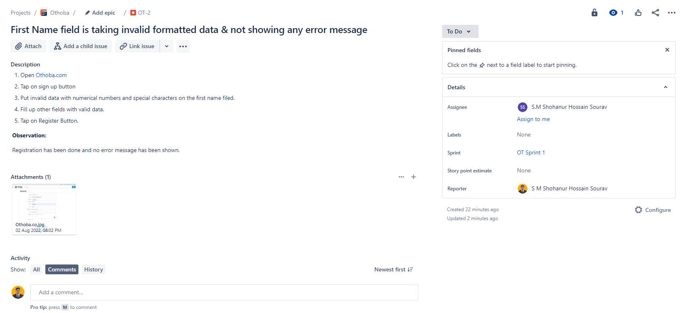

**Create a sprint to see the issue in board**

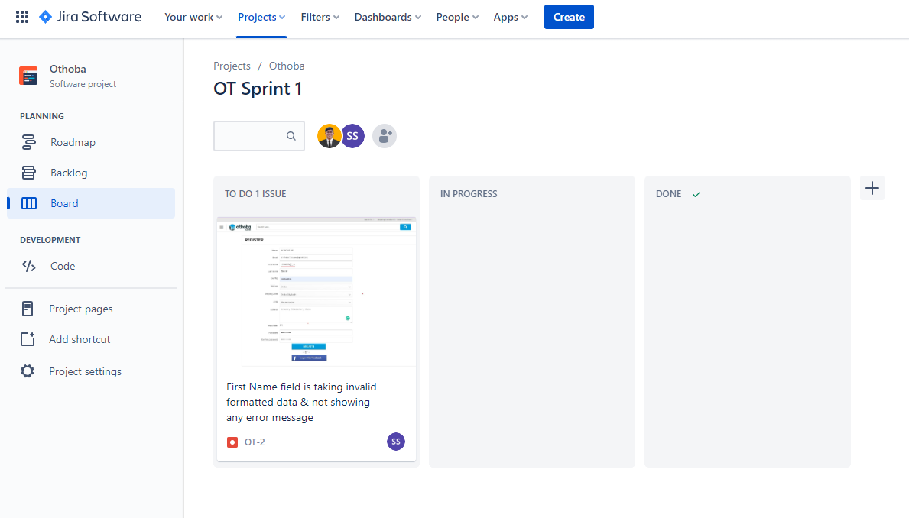

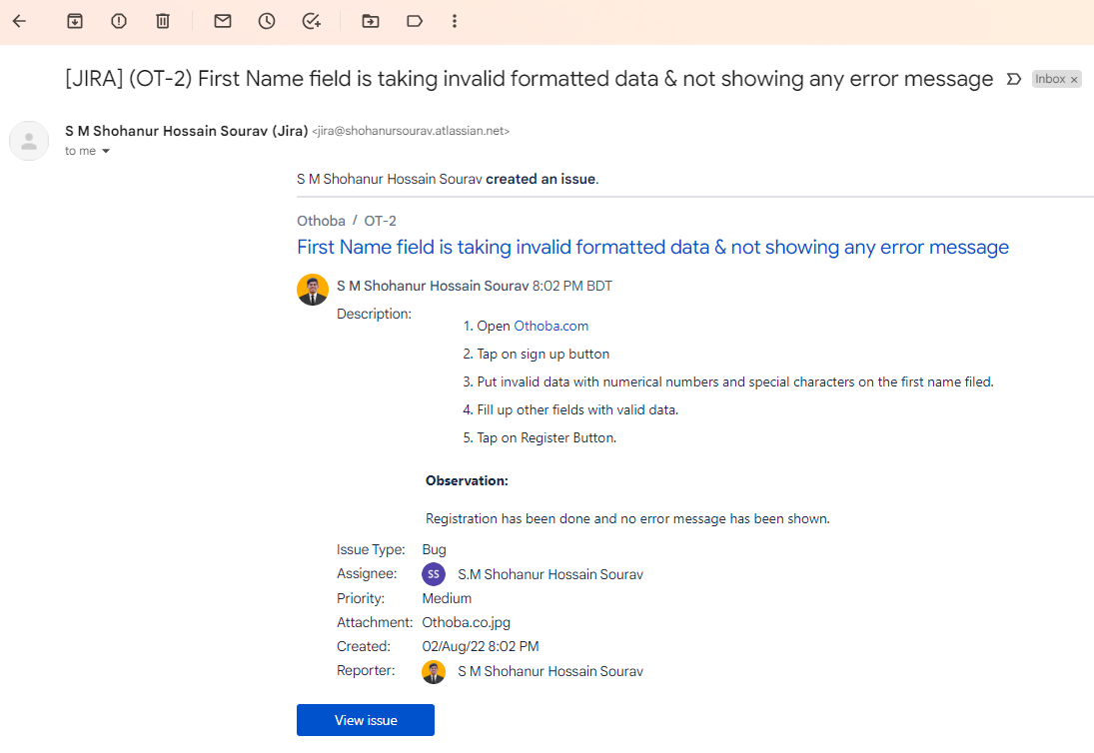**Ninth step:** Issue details will be sent to the developer’s email.

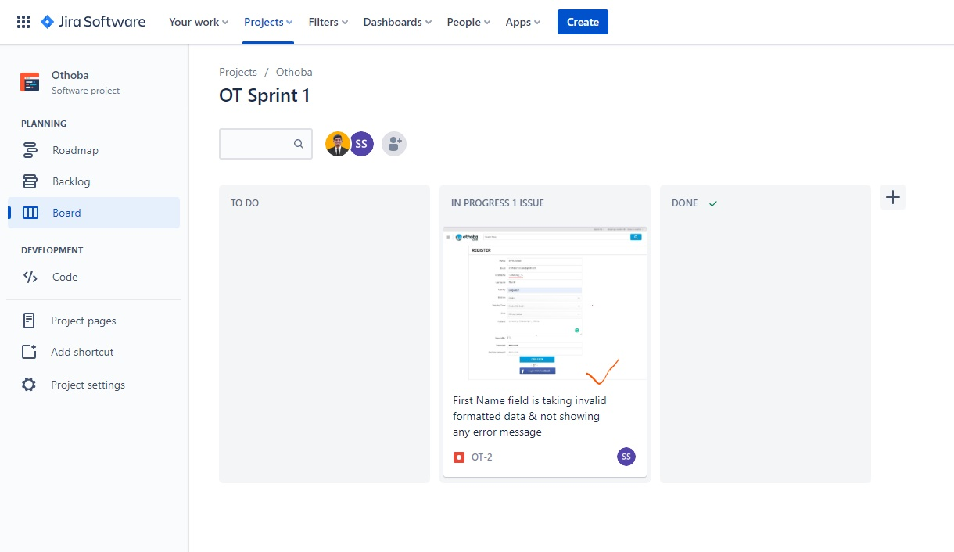**Tenth step:** When the developer will start fixing the bug, issue status will be “in progress”.

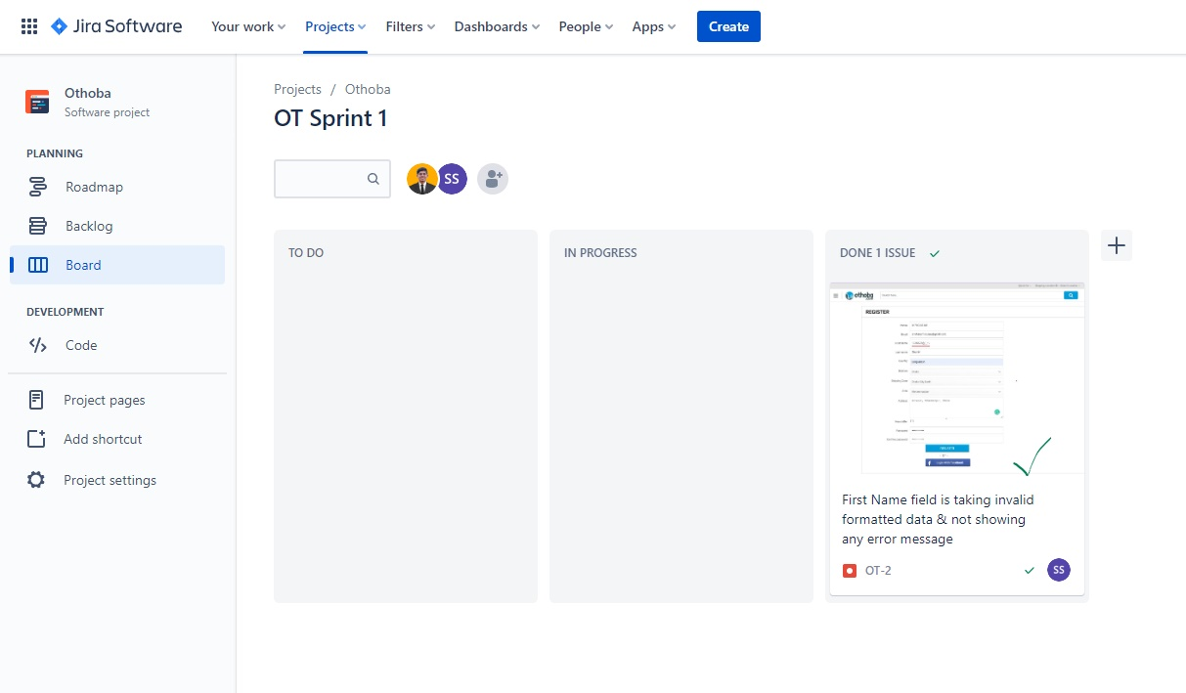**Eleventh step:** After fixing the bug, the status will be done. Developer also will get notification through email about the issue.

That’s how we can create issues of each bug and notify developers using Jira.